Republic of the Philippines
PALOMPON INSTITUTE OF TECHNOLOGY
Palompon, Leyte
COLLEGE OF TECHNOLOGY AND ENGINEERING
INFORMATION TECHNOLOGY DEPARTMENT

IT 118: Software Engineering

P14 – Deployment & Scaling Plan

Submitted as a Partial Requirement for this Subject by:
"M7 PRIME TECHNOLOGIST"
BSIT, 3rd Year, Section B

Alcuetas, Nicole D.
Mara-asin, Reynato B. Jr.*
Pamplona, John Rey T.
Son, Charles Sander M.
Villasan, Kristine Joy C.

Submitted to:

Rogelio G. Urboda Jr.
Subject Instructor

May 2026

Table of Contents

1. System Overview

1.1 Project Description
The Integrated Web-Based Enrollment Management System (EMS) is a centralized, browser-based platform developed specifically for PIT Laboratory High School. The system streamlines and supports the institution's annual enrollment process by automating three core administrative functions: student information encoding, document completeness verification, and school fee payment monitoring. Rather than replacing existing institutional workflows, the EMS serves as a supplementary digital platform that eliminates the reliance on fragmented paper forms and unlinked Microsoft Excel spreadsheets. It enables authorized school personnel to process student enrollments more accurately, confirm payment obligations in real time, and generate PDF digital receipts bearing unique transaction identifiers all within a single unified interface.

1.2 Target Users
1.2.1 Who will use the system?
The primary users of the Integrated Web-Based Enrollment Management System are the authorized administrative personnel of PIT Laboratory High School, specifically the school principal and authorized staff, who are directly responsible for overseeing document submission, verifying enrollment requirements, and confirming payment records during the enrollment period. The system is designed to augment their existing responsibilities by replacing repetitive manual tasks, such as handwritten form encoding, cross-referencing payment Excel files, and sequential document checking with automated digital workflows.
Secondary beneficiaries include students and their parents or guardians, who gain indirect advantages through a faster, more transparent, and better-organized enrollment experience. Although students and parents do not directly interact with the system interface, they benefit from shorter processing queues, accurately documented payment histories, and immediately issued digital receipts as proof of transactions. System access is restricted solely to authorized school personnel in accordance with institutional data privacy policies.
1.2.2 Expected number of users: The system is designed to support approximately 2 to 4 concurrent administrative users during peak enrollment operations. Based on observations at PIT Laboratory High School, enrollment processing is handled primarily by the school principal, supported by a small number of clerical staff. Student population records indicate approximately 200 to 350 enrolled students per school year across Grade 7 to Grade 10. The system is therefore architected for low-to-moderate concurrent user load but must sustain high transactional throughput during peak enrollment hours, when up to 35–40 student records may be processed per hour.

1.3 System Type
☑ Web Application
☐ Mobile Application
☐ Desktop Application
☐ Hybrid
The Integrated EMS is developed as a Web Application, accessible via standard internet browsers such as Google Chrome, Microsoft Edge, and Mozilla Firefox without requiring any local software installation beyond the browser itself. The system follows a client-server architecture wherein the user interface is rendered on the client side through HTML, CSS, and JavaScript, while all business logic, data validation, and database operations are executed server-side using PHP and a MySQL relational database. This architecture was selected because it allows simultaneous access by multiple authorized personnel from any device connected to the school's local network, eliminates version control issues common in desktop applications, and enables centralized data management with a single authoritative database. Web-based deployment also facilitates easier maintenance, patching, and future feature expansion by the development team without requiring end-user software updates.

2. Deployment Architecture
The Integrated EMS adopts a three-tier client-server architecture consisting of a presentation tier (web browser), an application tier (PHP-based web server), and a data tier (MySQL database server). All three tiers are hosted on a single dedicated on-premise server located within the PIT Laboratory High School campus, connected via the school's local area network (LAN). The client devices administrative workstations and laptops operated by school personnel communicate with the application server over HTTP/HTTPS. The application server processes all business logic including automated document verification, payment computation, and PDF receipt generation before querying or updating the MySQL database. This centralized on-premise model was chosen for data privacy compliance, institutional control, and cost-effectiveness given the school's operational scale and internet infrastructure constraints.

2.1 Architecture Diagram
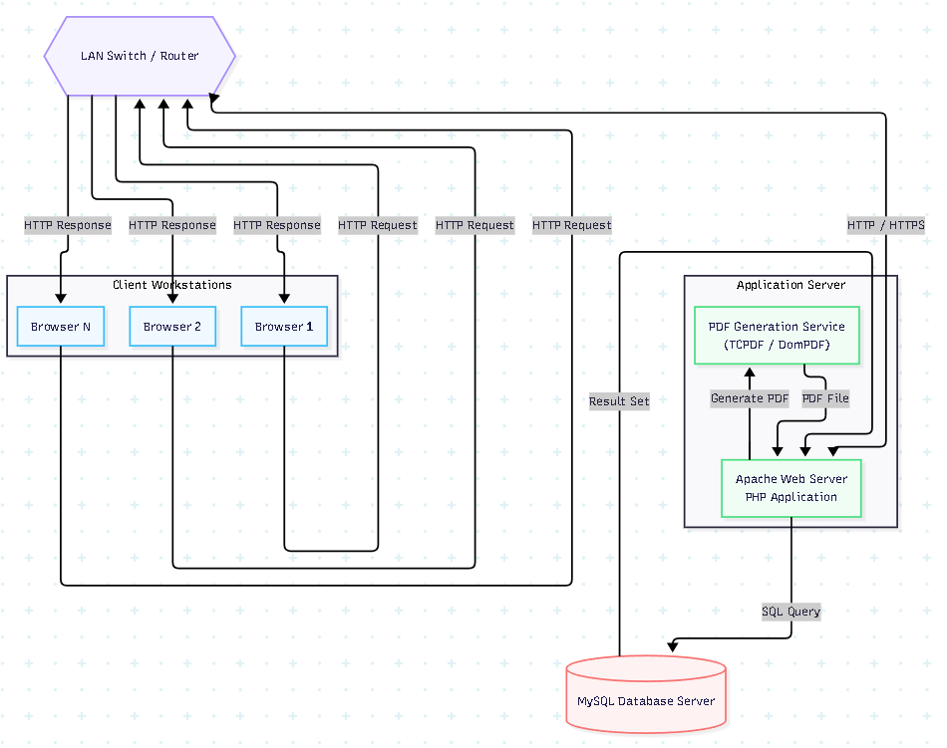
The diagram above illustrates the data flow within the EMS deployment. Administrative users access the system through their local web browsers, which send HTTP requests over the school LAN to the Apache web server. The PHP application layer processes the requests validating enrollment data, executing automated document completeness checks, computing payment totals, and invoking the PDF generation library for digital receipts. The application then queries or writes to the MySQL database, which serves as the single centralized repository for all student records, payment histories, and enrollment statuses. Responses are returned to the client as rendered HTML pages or downloadable PDF files.

2.2 Component Description
Component | Description
Client | e.g., browser/mobile app
Application Server | handles business logic
Database | stores data
PHP Application Layer | The core business logic tier of the system. Implemented in PHP, it manages user authentication and session control, executes automated document verification routines, computes school fee totals and outstanding balances, and coordinates data flow between the browser and the database.
MySQL Database Server | The data persistence layer. Stores all structured records including student profiles, enrollment statuses, document submission flags, fee payment histories, and transaction receipts. Uses normalized relational tables to enforce data integrity and minimize redundancy.
Session & Authentication Module | Manages secure login sessions for all authorized users using PHP sessions and hashed password validation (bcrypt). Enforces role-based access control to ensure only designated personnel can access sensitive student and financial data.
LAN Network Infrastructure | The school's local area network (router and switch) that connects all client workstations to the on-premise server. All system communications occur within this internal network, isolating data from the public internet during normal operations.

3. Deployment Environment
The EMS deployment follows a structured three-environment lifecycle: Development, Testing/Staging, and Production. Each environment is purposefully isolated to ensure that active development does not disrupt live operations and that all system changes are validated before being released to administrative end-users. Given the school's resource constraints, the development and testing environments are maintained on developers' local machines using XAMPP, while the production environment runs on a dedicated on-premise server within the school's LAN.

3.1 Environment Setup
Environment | Purpose
Development | Active coding, unit testing, and local feature development by team members.
Testing/Staging | System integration testing, user acceptance testing (UAT), and pre-release validation before deployment.
Production | The live operational system used by PIT Laboratory High School administrative personnel during the enrollment period.

3.2 Deployment Flow
The system transitions through environments following a controlled release process, as illustrated in the deployment flow diagram below. Development occurs on individual team members' local XAMPP environments, with source code version-controlled in a shared Git repository hosted on GitHub. Once a feature or bug fix is complete, it is pushed to the shared repository and merged into the 'staging' branch after peer code review.
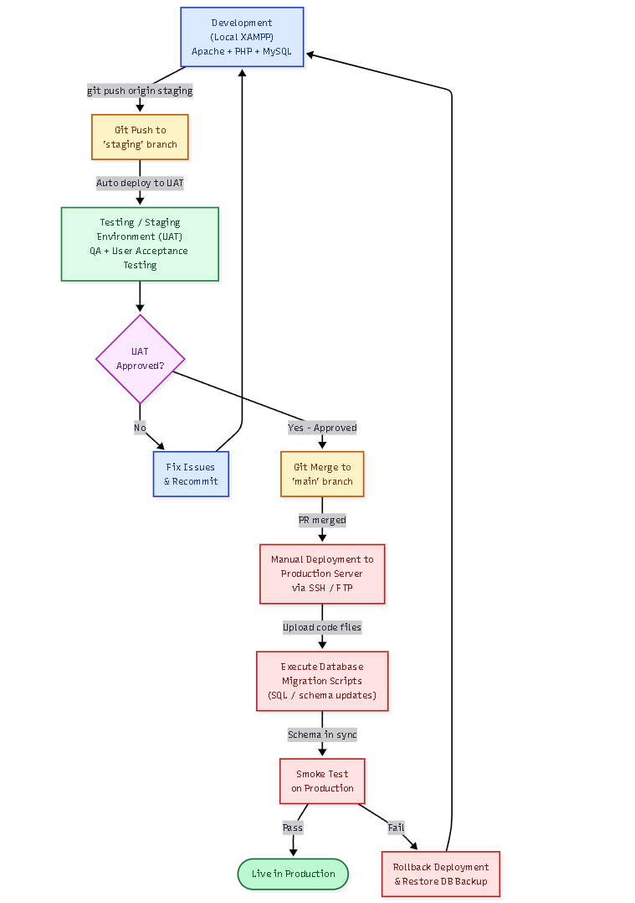In the Testing/Staging phase, the team conducts integration tests, verifies automated document verification logic, and performs user acceptance testing (UAT) with school staff. Upon approval from the subject instructor and system stakeholders, the staging branch is merged into the 'main' production branch. Deployment to the production server is performed manually by the lead developer via secure FTP or SSH file transfer, followed by the execution of database migration scripts to apply any schema changes. A post-deployment smoke test confirms that core features—login, student enrollment encoding, document verification, payment recording, and PDF receipt generation—are functioning correctly before the system is handed over for live use.

4. Scaling Strategy
The scaling strategy for the Integrated EMS is designed around the institution's operational profile: a secondary school with a student population of approximately 200–350 students and a small administrative team of 2–4 concurrent system users. Given this scale, the primary scaling concern is not sustained high-volume traffic but rather handling peak enrollment throughput during concentrated registration periods. The scaling approach prioritizes vertical scaling—the enhancement of the on-premise server's hardware resources—as the most pragmatic and cost-effective solution for the school's operational context.

4.1 Expected Load
4.1.1 Estimated number of users: The system is expected to serve 2 to 4 concurrent administrative users under normal operational conditions. These users consist of the school principal and any supporting clerical staff authorized to operate the enrollment system. During off-peak periods, as few as one administrator may be actively using the system for record lookups or payment status monitoring.
4.1.2 Peak usage scenario
The most demanding operational scenario occurs at the start of the school year's official enrollment period, typically spanning 5 to 10 consecutive days. During peak enrollment hours (8:00 AM to 12:00 PM), the system may process 35 to 40 student transactions per hour, as observed from enrollment queue data at PIT Laboratory High School. Each transaction involves student information encoding, automated document verification, and payment recording, resulting in multiple database read/write operations per student. Additionally, PDF receipt generation for each completed payment introduces temporary processing overhead on the server.
A secondary peak scenario occurs when bulk enrollment data exports or summary reports are generated at the end of the enrollment period, which may require larger database queries across the full student dataset. The system must sustain acceptable response times (under 3 seconds per transaction) throughout these peak windows without service interruption.

4.2 Scaling Approach
☑ Vertical Scaling (increase resources)
☐ Horizontal Scaling (add servers)
Vertical scaling is the selected approach for the Integrated EMS, and it is the most appropriate strategy for this deployment context. The system operates within a single on-premise school server that serves a small, geographically confined user base on a closed LAN. The user concurrency ceiling (2–4 simultaneous users) and the transaction volume (approximately 35–40 students per peak hour) do not justify the complexity and cost of horizontal scaling architectures such as load-balanced server clusters.
Vertical scaling means that when additional computational resources are required whether due to a growing student population, expanded system features, or increased administrative staff the school upgrades the existing server's hardware: increasing RAM, upgrading to a faster CPU, or expanding storage capacity. This approach requires no changes to the application's architecture or codebase and aligns with the school's institutional constraints regarding budget, IT staffing, and infrastructure management capabilities.

4.3 Scaling Plan
4.3.1 When scaling is needed
Scaling should be considered when the system exhibits measurable performance degradation against baseline benchmarks established during initial deployment. Specifically, scaling is warranted under any of the following conditions: (1) average page response times consistently exceed 3 seconds during peak enrollment hours as logged by server-side monitoring tools; (2) the MySQL server's query execution time for core transactions student record inserts, payment updates, enrollment status lookups exceeds 500 milliseconds on average; (3) the student population of PIT Laboratory High School grows beyond 500 enrolled students, significantly increasing database record volume and PDF generation load; (4) the number of authorized concurrent system users expands to 8 or more as additional administrative roles are granted system access; or (5) new modules—such as online document uploads, parent portal access, or integration with DepEd's Learner Information System (LIS) are introduced, substantially increasing application complexity and server resource demands.
4.3.2 How scaling will be triggered
Scaling decisions will be triggered through a manual monitoring and review process, given the absence of a commercial cloud infrastructure with automated auto-scaling capabilities. The lead system administrator (typically the assigned IT faculty or student developer) will monitor server performance using lightweight open-source tools installed on the Ubuntu production server, including htop for real-time CPU and memory utilization monitoring and MySQL's slow query log feature for database performance analysis.
A performance review will be conducted at the end of each enrollment period. If logged metrics indicate that the defined performance thresholds have been breached consistently (on more than 20% of transactions during the peak window), the development team will prepare a hardware upgrade recommendation for school administration. The recommendation will specify the required RAM increase, CPU upgrade, or storage expansion, accompanied by cost estimates and a proposed implementation timeline during the academic off-season (typically April–May, before the next enrollment cycle begins).

5. Availability & Reliability
Ensuring the continuous availability of the EMS during the enrollment period is critical, as system downtime directly disrupts the registration of students and the confirmation of payments. The availability strategy for the EMS is designed around the institution's on-premise deployment constraints, prioritizing preventive maintenance, data redundancy through regular backups, and clearly defined downtime response procedures. While enterprise-grade high-availability solutions such as multi-server clustering are beyond the scope of this project, the following conceptual and practical measures are implemented to maximize system uptime within the school's operational environment.

5.1 Availability Strategy
5.1.1 Load balancing (conceptual)
Given that the EMS is deployed on a single on-premise server serving a maximum of 4 concurrent users, traditional load balancing across multiple servers is not operationally necessary at this scale. However, at the application level, a conceptual load management approach is implemented through Apache's built-in MaxRequestWorkers configuration, which limits the number of simultaneous PHP processes to prevent any single heavy request (such as a bulk PDF generation batch) from consuming all available server memory and degrading response times for other concurrent users.
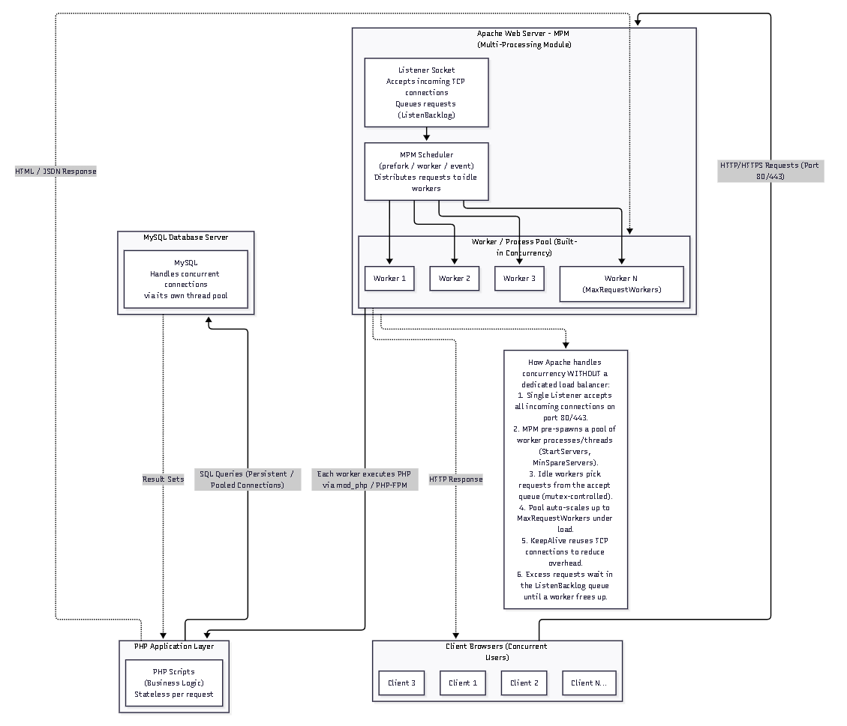
5.1.2 Redundant systems
To protect against data loss and ensure recoverability after hardware or software failures, the EMS implements a two-level data redundancy strategy. At the database level, automated MySQL dump scripts create full database backups stored in a separate directory on the production server and copied to an external USB drive maintained by the school's designated IT personnel. At the application level, all student records, payment histories, and generated PDF receipts are stored persistently in the MySQL database and the server's file system, respectively, ensuring that no transaction data exists solely in temporary memory.
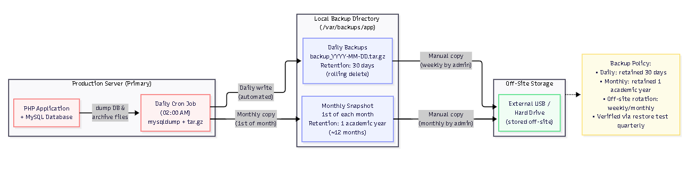

5.2 Downtime Handling
5.2.1 What happens if system fails?
In the event of an unexpected system failure during the enrollment period, the following escalation procedure will be followed. The school's IT-designated personnel (or student developer assigned to system maintenance) will be immediately notified by administrative staff. A system status check will be performed to determine whether the failure originates from the web server process (Apache crash), the database service (MySQL failure), the network infrastructure (LAN switch or router fault), or a power disruption. If the failure cannot be resolved within 30 minutes, enrollment operations will temporarily revert to the existing manual process—using paper forms and Excel spreadsheets—to avoid delays in student registration. Once the system is restored, all manually recorded data from the downtime window will be backloaded into the EMS database to maintain record integrity and continuity.
5.2.2 Backup Strategies
The EMS implements a structured three-tier backup strategy to ensure data durability and rapid recovery capability. First, automated nightly database backups are executed via a MySQL dump cron job at 11:00 PM daily, generating compressed SQL dump files stored in a designated /backups directory on the production server. These local backups are retained for a rolling 30-day window, with monthly snapshots retained for the full academic year.
Second, weekly manual backups are copied from the production server to a password-protected external hard drive maintained by the school principal's office. This off-server copy protects against catastrophic server hardware failure, including disk corruption or physical damage to the server unit. Third, prior to any scheduled system update or new feature deployment, a pre-deployment backup is executed to create a restore point, allowing the system to be rolled back to the last known stable state if the update introduces critical errors. Database restoration drills will be conducted by the development team at the end of the academic year to verify the integrity and completeness of backup files.

6. Failure & Risk Analysis
A comprehensive failure and risk analysis was conducted to identify potential failure scenarios that could affect the operation of the Integrated EMS during the critical enrollment period. Given the system's on-premise deployment within a school environment, risks encompass technical failures, infrastructure limitations, and human operational errors. The table below documents identified failure scenarios along with their potential impact on system operations and administrative workflows.

6.1 Possible Failures
Failure Scenario | Impact
Server crash | system unavailable
Database failure | data inaccessible
Network issue | users disconnected
MySQL database failure | All data operations—student record reads, payment writes, enrollment status updates—are halted. The system interface may load but will throw database connection errors for every action.
School LAN network outage | All connected client workstations lose access to the application server. Even if the server is operational, no users can reach the system.
Power outage | Abrupt server shutdown may corrupt in-progress database writes or active PHP sessions, potentially causing partial transaction records and data inconsistency.
PDF generation service failure | Digital receipt generation is disabled. Enrollment processing can continue, but payment receipts cannot be issued. Staff must manually acknowledge payments until the issue is resolved.
Session timeout causing unsaved form data loss | If an administrative user's PHP session expires mid-transaction (e.g., while encoding a lengthy student record), all unsaved form input is lost, requiring re-entry

6.2 Mitigation Strategies
MySQL Database Failure
Similar to the Apache watchdog, a separate cron job monitors the MySQL service status at 5-minute intervals and triggers an automatic restart if the service is found stopped. Additionally, the application's PHP database connection layer implements a retry mechanism with three reconnection attempts before returning a user-friendly error page that informs administrative staff to contact the system administrator. Nightly mysqldump backups ensure that the most recent day's data can be restored within 30 minutes of a full database recovery operation.
LAN Network Outage
Network infrastructure failures (switch or router faults) are addressed through two mitigation measures. First, the school is advised to maintain one spare network switch for rapid hardware replacement. Second, the system documentation includes an offline contingency procedure: in the event of a total network failure, administrative staff revert to pre-printed enrollment forms and Excel spreadsheets as the interim recording method, with all data to be backloaded into the EMS once connectivity is restored. This ensures that enrollment operations are never completely halted by a network failure.
Power Outage
The production server is connected to an Uninterruptible Power Supply (UPS) unit capable of sustaining server operations for a minimum of 15 minutes during a power interruption. This grace period allows the system administrator to execute a controlled server shutdown procedure (saving all in-progress database writes and closing active PHP sessions gracefully) before the UPS battery is depleted. The UPS protects against the abrupt shutdown scenario that could lead to InnoDB database corruption. Additionally, MySQL's InnoDB storage engine provides transaction logging (redo/undo logs) that enables crash recovery after uncontrolled shutdowns.
PDF Generation Failure
The TCPDF library integration is wrapped in a PHP try-catch exception handler. If receipt generation fails for any reason (memory allocation error, file permission issue, or library exception), the system catches the error, logs it to the application error log, and displays a user notification indicating that the receipt could not be generated at this time. The enrollment and payment records are still saved to the database successfully—only the PDF output is affected. Administrative staff can manually re-trigger receipt generation from the payment history view once the issue is resolved.
Session Timeout and Data Loss
The PHP session lifetime is configured to 60 minutes of inactivity—longer than a typical enrollment transaction—to reduce the frequency of session timeouts during peak processing. Additionally, the enrollment encoding form implements client-side auto-save logic using JavaScript's localStorage to periodically save draft form data to the browser's local storage every 30 seconds. If a session expires, the user is prompted to log in again, after which the system restores the saved draft data automatically, preventing complete re-entry.

7. Security Considerations
7.1 Authentication (login system)
The EMS implements a form-based authentication system using PHP session management. All administrative users must authenticate with a registered username and password before gaining access to any system functionality. User credentials are stored in the MySQL database with passwords hashed using PHP's password_hash() function, which applies the bcrypt algorithm with a computational cost factor of 12. Bcrypt is a deliberately slow hashing algorithm that significantly increases the computational effort required for brute-force or dictionary attacks against the stored password hashes.
Upon successful authentication, a unique PHP session identifier is generated and stored in a browser cookie with the HttpOnly flag set (preventing JavaScript access) and, where HTTPS is available, the Secure flag to restrict transmission to encrypted connections only. PHP sessions are invalidated after 60 minutes of inactivity and completely destroyed upon user logout. To protect against brute-force login attacks, the system implements a login attempt counter stored in the database: after five consecutive failed attempts from the same username within a 15-minute window, the account is temporarily locked and requires administrator intervention to unlock.
7.2 Data protection (encryption concept)
Sensitive data transmitted between client browsers and the Apache web server is protected using HTTPS (HTTP over TLS/SSL). A self-signed SSL certificate is installed on the production Apache server, enabling HTTPS connections that encrypt all request and response payloads in transit. This protects student personal information, payment records, and authentication credentials from interception on the school LAN. While a self-signed certificate does not provide third-party certificate authority validation (which is more relevant for public-facing internet systems), it provides equivalent encryption strength for the school's closed internal network environment.
At the database level, student records and payment data are stored in plaintext within the MySQL database, as field-level encryption would add implementation complexity beyond the project scope. However, the MySQL server is configured to accept connections only from localhost (the same server), preventing remote network access to the database directly. Database administrative credentials are stored in a PHP configuration file located outside the web server's public document root, ensuring they cannot be accessed via a browser request.
7.3 Access Control
The EMS implements Role-Based Access Control (RBAC) with two defined user roles: Administrator and Staff. The Administrator role (assigned to the school principal and vice-principal) has full system access, including the ability to encode and edit student records, confirm document verification, record payments, generate receipts, manage user accounts, and view all reports and audit logs. The Staff role (assigned to supporting clerical personnel) has limited access restricted to viewing enrollment statuses and recording payment data, but cannot modify enrollment records or manage user accounts.
All PHP pages within the system perform a session authentication check at the page level: if no valid authenticated session is found, the user is immediately redirected to the login page. Additionally, role-level authorization checks are performed before rendering sensitive interface elements—for example, the user management panel is only visible and accessible to Administrator-role sessions. Direct URL manipulation (e.g., attempting to navigate to /admin/users without an Administrator session) returns a 403 Forbidden response.

8. CI/CD Integration
8.1 How CI/CD connects to deployment
The Continuous Integration and Continuous Deployment (CI/CD) pipeline for the EMS is implemented using GitHub as the version control and collaboration platform, with GitHub Actions as the automated CI workflow engine. The pipeline bridges the gap between the development environment and the production server by automating code quality checks and test execution on every push to the shared repository. This ensures that integration errors, syntax failures, and failed unit tests are detected immediately in the development phase before code reaches the staging or production environments directly connecting CI outcomes to deployment readiness decisions.
8.2 When deployment occurs
Deployment to the staging environment occurs automatically when a developer pushes a feature branch and creates a pull request targeting the 'staging' branch in the GitHub repository. The CI pipeline runs automated checks on the pull request branch; if all checks pass, the merge to staging is permitted and the staging environment is updated manually by the lead developer for UAT. Deployment to the production environment occurs manually and deliberately, following a structured process: after the project team and subject instructor formally approve the UAT results, the staging branch is merged into the protected 'main' branch, and the lead developer performs the production deployment during a scheduled maintenance window (typically a non-enrollment day or early morning before school hours).
8.3 What is automated
The following CI tasks are automated through the GitHub Actions workflow configuration (.github/workflows/ci.yml):
- PHP Syntax Validation: On every push, PHP's built-in linter (php -l) is executed against all PHP source files to detect syntax errors before the code is reviewed or deployed.
- PHPUnit Test Execution: Automated unit tests covering core business logic functionssuch as fee total computation, document completeness verification logic, and session authentication helpers—are executed in the CI environment to verify that new code changes do not break existing functionality.
- Code Style Enforcement: PHP CodeSniffer (phpcs) is run to enforce consistent code formatting standards across all team members' contributions, improving long-term maintainability.
- Database Migration Dry-Run: SQL migration scripts are validated against a test database instance in the CI environment to confirm schema changes are syntactically correct before they are applied to staging or production databases.
Build Artifact Packaging: Upon a successful merge to the 'main' branch, GitHub Actions packages the application files into a deployment-ready archive, which is then manually transferred to the production server by the lead developer via SFTP.

9. Tools & Technologies
Name | Purpose
Apache HTTP Server 2.4 (Hosting platform) | Serves the EMS web application to client browsers over HTTP/HTTPS on the school's on-premise server. Manages PHP request routing through mod_php and enforces access restrictions via .htaccess configuration.
MySQL 8.0  (Database) | Relational database used to store and manage all persistent system data: student profiles, enrollment statuses, document submission records, payment transactions, and generated receipt metadata.
PHP 8.1  (Programming language) | Server-side scripting language used to build the EMS application logic, including student record management, automated document verification routines, payment computation, session handling, and database interaction.
GitHub Actions  (CI Tools) | Automated CI workflow engine integrated with the GitHub repository. Executes PHP linting, PHPUnit tests, code style checks, and database migration validation on every push or pull request.
GitHub Actions  (CD Tools) | Automated CD workflow engine integrated with the GitHub repository. Executes PHP linting, PHPUnit tests, code style checks, and database migration validation on every push or pull request.

10. Reflection
10.1 What challenges did you encounter in designing deployment?
One of the most significant challenges encountered in designing the deployment architecture was reconciling enterprise-level software engineering best practices—such as multi-environment pipelines, automated CI/CD workflows, and containerized deployments—with the operational and financial constraints of a single on-premise school server. Academic resources on deployment planning typically reference cloud infrastructure (AWS, Google Cloud, Azure) or containerization tools (Docker, Kubernetes) that are not practically available within PIT Laboratory High School's IT environment. This required the team to thoughtfully adapt these concepts into simpler but equally principled equivalent solutions—for example, using cron-based service health checks as a substitute for commercial load balancer health probes, and structured Git branching as a substitute for automated deployment pipelines.
A second challenge was designing for the system's unique performance profile: infrequent use with extreme short-term peaks during enrollment. Standard system capacity planning often assumes steady or gradually growing load, whereas the EMS must handle virtually zero load for most of the academic year and then sustain peak throughput for 5–10 concentrated enrollment days. Designing the backup strategy, session configuration, and scaling triggers to account for this intermittent usage pattern required careful analysis of the school's actual enrollment workflows rather than reliance on generic benchmarks.
10.2 What assumptions did you make?
The deployment plan was developed on several foundational assumptions about the operational context of PIT Laboratory High School. First, it is assumed that the school has or will acquire a dedicated on-premise server with minimum specifications of 8GB RAM, a quad-core 64-bit processor, 500GB HDD, and a stable local area network connecting administrative workstations. Second, it is assumed that a designated school IT personnel or faculty member will be available to perform scheduled maintenance tasks, execute backup transfers to external media, and respond to service disruption alerts. Third, it is assumed that the school's LAN provides reliable internal connectivity during enrollment hours, even if public internet connectivity is intermittent since the system is designed for LAN-only access.
Fourth, it is assumed that administrative users will be given an orientation session on the system's login procedures, basic navigation, and error reporting protocols prior to the enrollment period, reducing the probability of operator-induced errors. Fifth, the choice of PHP over a framework-based solution (such as Laravel) was made with the assumption that the project team possesses sufficient raw PHP proficiency for the system's current scope, and that a framework's additional abstraction layers would introduce unnecessary complexity for a two-semester capstone timeline.
10.3 What would you improve in a real-world system?
In a real-world production deployment beyond the capstone scope, the most impactful improvement would be migrating the system from on-premise hosting to a cloud-based Infrastructure as a Service (IaaS) platform such as AWS EC2, Google Cloud Compute Engine, or a local Philippine cloud provider. Cloud hosting would provide automated backups, managed database services (e.g., Amazon RDS for MySQL) with built-in replication, elastic vertical scaling without hardware procurement lead times, and HTTPS certificates from trusted Certificate Authorities—all with a predictable monthly cost that could fit within a small school's technology budget.
A second critical improvement would be the implementation of containerization using Docker. Packaging the PHP application, Apache server, and MySQL database into Docker containers with a docker-compose.yml configuration would eliminate environment discrepancies between development and production instances ('it works on my machine' issues), simplify the onboarding of new developers, and provide a reproducible deployment unit that can be migrated between servers in minutes. In conjunction with Docker, a proper CI/CD platform such as GitHub Actions with automated production deployment (rather than the current manual SFTP transfer) would complete the pipeline and reduce the risk of human error during releases.
Third, the system would benefit substantially from the addition of comprehensive audit logging—a tamper-evident log table in MySQL recording every data modification (who changed what, and when) for accountability and forensic analysis. In an official institutional system handling student academic and financial records, such audit trails are not merely good practice but may be required by data governance and educational data privacy regulations such as the Philippine Data Privacy Act (Republic Act 10173).

11. Appendix
11.1 Additional diagrams
Entity-Relationship Diagram (ERD) of the MySQL database schema. Include entities for: Student, Enrollment Record, Document Submission, Payment Transaction, Receipt, Fee Type, Form Section, Learning Modality and User.
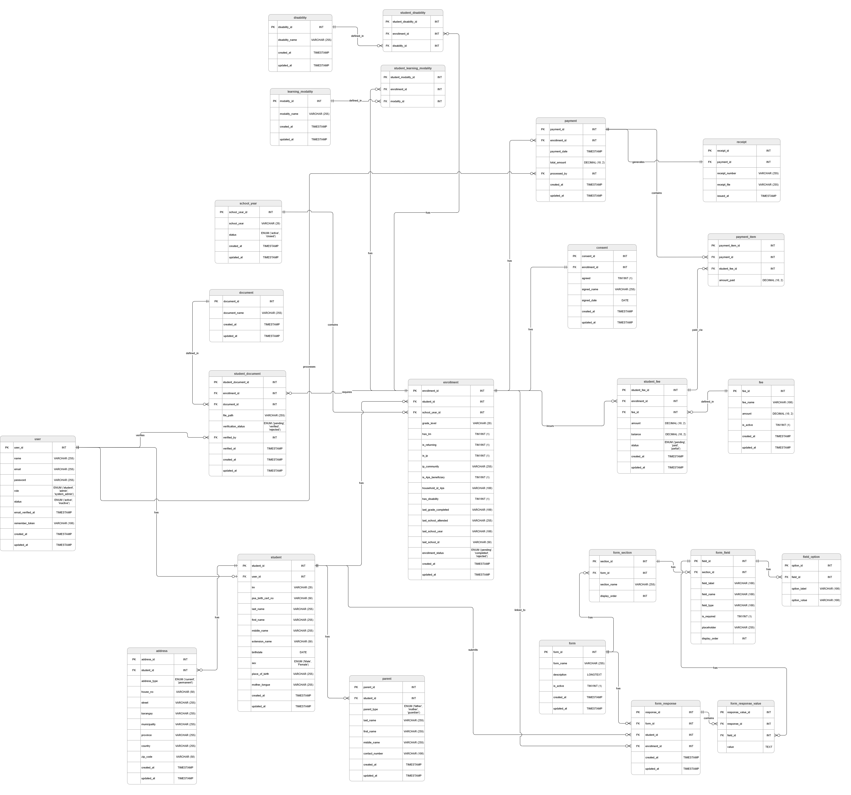
11.2 Screenshots
Put your screenshots here... Put summary/description after per screenshot…

11.3 Notes (optional)
Put your notes here in bullet form, if there are...

